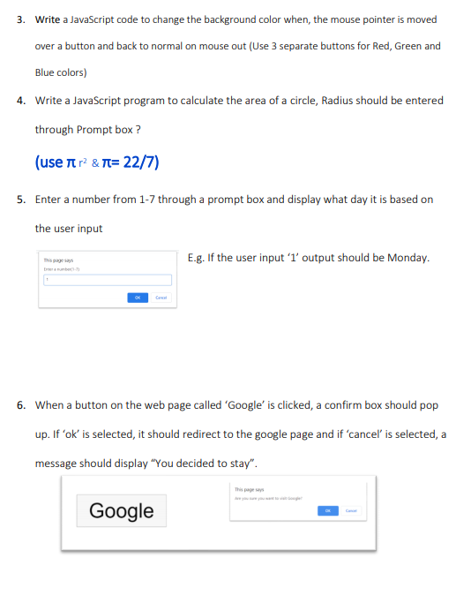**JavaScript – Tutorial**

05)

<html>

<head>

<title>Day of the Week</title>

</head>

<body>

<h1>Day of the Week</h1>

<button onclick="getDayOfWeek()">Get Day of the Week</button>

<script>

function getDayOfWeek() {

const dayNumber = parseInt(prompt("Enter a number from 1 to 7:"));

if (isNaN(dayNumber) || dayNumber < 1 || dayNumber > 7) {

alert("Invalid input. Please enter a number from 1 to 7.");

return;

}

const daysOfWeek = ["Sunday", "Monday", "Tuesday", "Wednesday", "Thursday", "Friday", "Saturday"];

const dayName = daysOfWeek[dayNumber - 1];

alert(`The day of the week is: ${dayName}`);

}

</script>

</body>

</html>

06)

<!DOCTYPE html>

<html>

<head>

<title>Google Redirect</title>

</head>

<body>

<h1>Click the 'google' button to proceed to Google or cancel to stay.</h1>

<button onclick="redirectToGoogle()">Google</button>

<script>

function redirectToGoogle() {

const confirmation = confirm("Do you want to proceed to Google?");

if (confirmation) {

window.location.href = "https://www.google.com";

} else {

alert("You decided to stay.");

}

}

</script>

</body>

</html>